***ASSIGNMENT-1***

Q-1 What is software? What is software engineering?

ANS - Software is a collection of a instruction who has follow a programm and manage a all thing in a database and a any type of a machine.

----> Software engineering who has approach to a directly software devlopment .

----> And it all has work in a desing who has followed byy given

planning---->analysis---->designing---->implementation---->testing---->maintain.

Q-2 Explain types of software.

ANS- Software has a two type

1. system software

2. application software

----> system software - system software On account of system software, it helps client just as equipment to work and associate effectively with one another. Ordinarily, this is bit of software that is utilized to deal with conduct of PC equipment so client needs essential usefulness. Basically, system software is basically go-between or middle of road layer between client and equipment.

----> application software - They are likewise prevalently known as end-client programs or even efficiency programs which help client in finishing different undertakings like leading on web research, making notes, planning illustrations, looking after records, completing computations or in any event, playing PC games. They basically lie over system software. They are really utilized by end-client just as have explicit usefulness or undertakings which they are intended to perform. These software are regularly evolved through custom software improvement, in light of prerequisites of clients.

Q-3 What is SDLC? Explain each phase of SDLC.

ANS - SDLC full form is software devlopment life cycle who has help for all software engineer to make a website and programming.

---->

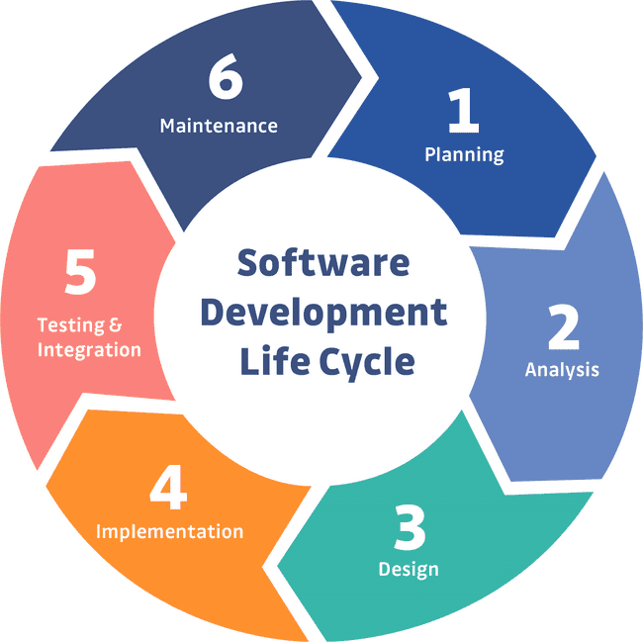

----> planning - planning is very important and first step in SDLC

----> analysis - analysis is a analys by any one member of a team to a project and define a project .

---->design - design is a represent part of a website project its represent to a front end engineering.

---->implementation - implementation is representation a beck end engineering in project.

---->testing - after all makig a website all data goes to a testing tester test a web site and creating a bug and solve it.

---->maintenace - after all coding ro testing website has maintain byy ba server.

Q-4 What is DFD? Create a DFD diagram on Flipkart.

ANS- DFD is data flow diagram its represent a data flowing direction and types also .

FLIPKART

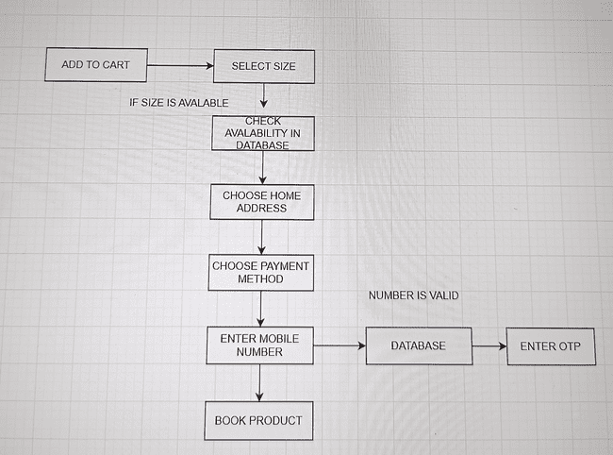

Q-5 What is Flow chart? Create a flowchart to make addition of two numbers.

ANS- Flowcharts are nothing but the graphical representation of the data or the algorithm for a better understanding of the code visually. It displays step-by-step solutions to a problem, algorithm, or process. It is a pictorial way of representing steps that are preferred by most beginner-level programmers to understand algorithms of computer science, thus it contributes to troubleshooting the issues in the algorithm.

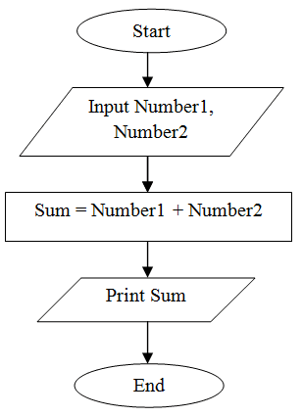

Q-6 What is Use case Diagram? Create a use-case on bill payment on paytm.

ANS- Use case diagram is define a work of a carecter in a chart.

----> it has a actor in that diagram who has shown own work by arrow.

